目录

**1 Install Openethereum 1**

**2 Brief introduction of Openethereum 2**

2.1 commands 2

2.2 Chain Specification 3

2.3 How to Set Up a POA Blockchain Network Using Openethereum? 5

**3. Hard Fork 10**

# 1 Install Openethereum

* 1. download from Repo: <https://github.com/openethereum/openethereum> and Build Openethereum Client
  2. Prerequisite:

Rust: curl https://sh.rustup.rs -sSf | sh

Perl: sudo apt-get update

sudo apt-get install perl

perl -v to verify the installation

Yasm: sudo apt-get update

sudo apt-get install yasm

* 1. Build: cargo build --release --features final

This generates ./target file

Or download directly from: https://github.com/openethereum/openethereum/releases

sudo chmod +x openethereum

* 1. Start openethereum: ./target/release/openethereum

This will start to sync the Ethereum mainnet blockchain

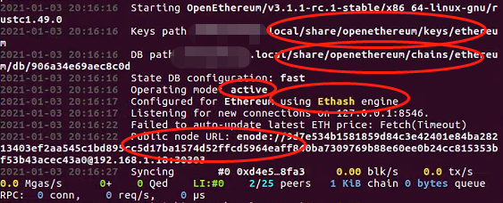

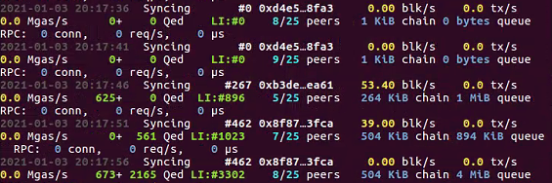

# 2 Brief introduction of Openethereum

## 2.1 commands

./openethereum --help

./openethereum --chain (ropsten) specify the network to sync with

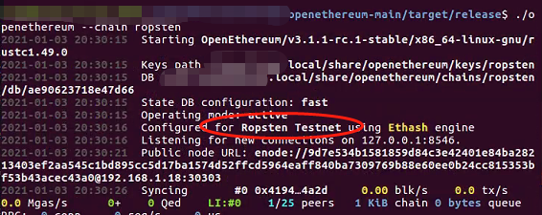

./openethereum --pruning: shows how much block history we are going to save --pruning archive

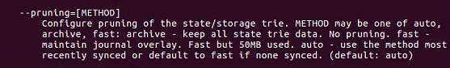

try ./openethereum --pruning archive

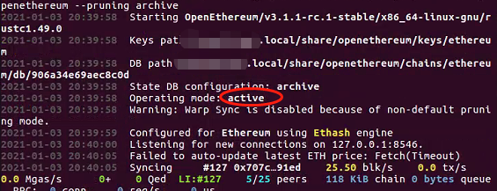

## 2.2 Chain Specification

Template

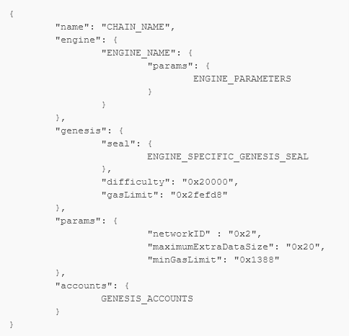

POW Consensus:

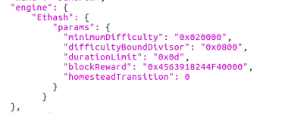

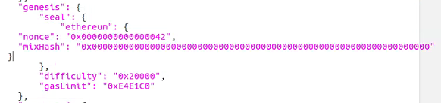

* Geth to set up POW for an Alter Coin

POA:

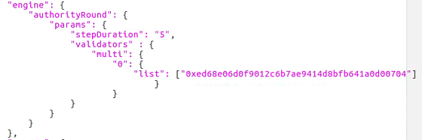

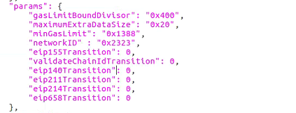

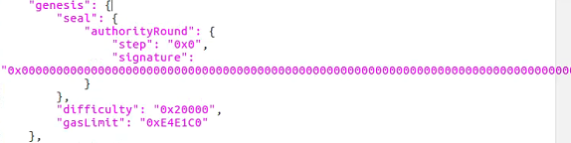

## 2.3 How to Set Up a POA Blockchain Network Using Openethereum?

1. set up the chain spec json file for the network

1. There are two ways to start a network: setting up a toml file to configure the parity client parameters or typing command with parameters

./openethereum --chain demo-spec.json

./openethereum -c node0.toml



If we just specify chain then they are the same

1. create a validator account in openethereum

./openethereum account new ->

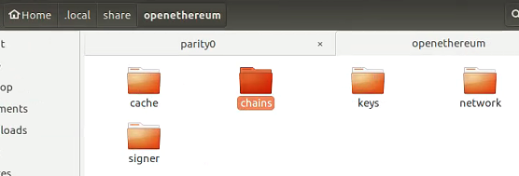

Chains: Store blockchain data

Keys: All the private keys created by this client

Network: peer data

Cache: all unsealed transactions and so on

Signer: Metamask injection(make a transaction by a signer, rather than by the accounts with pk stored in this client)

*go through each folder

./openethereum account new --chain demo-spec.json --key-path parity0/keys

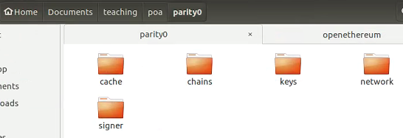

https://openethereum.github.io/Configuring-OpenEthereum

1. Start up a real private network and connect to it using Metamask

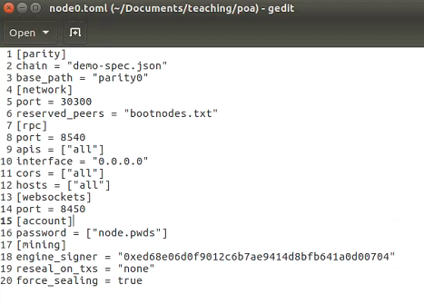

* Explain the parameters one by one

Cors if don’t set this to be all and interface to 0.0.0.0, then Metamask can’t connect to the blockchain

Start the network: ./openethereum - c node0.json

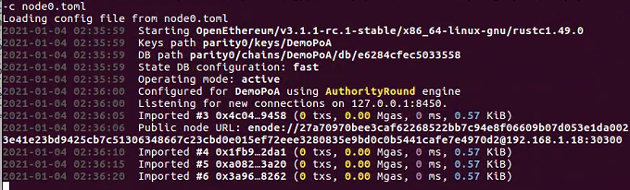

Use Metamask to connect to the BlockChain

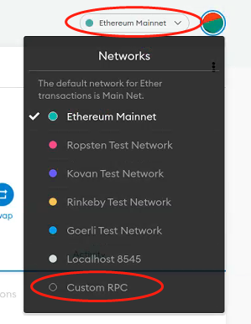

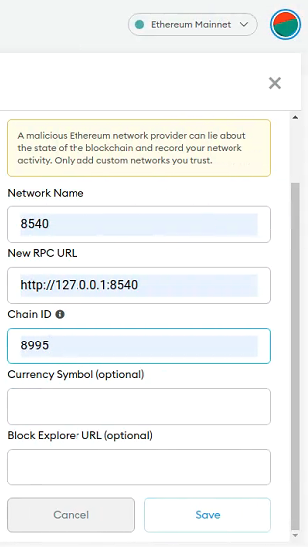

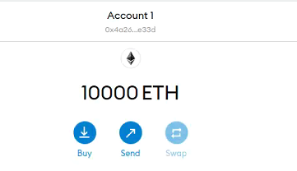

* Make a Transfer

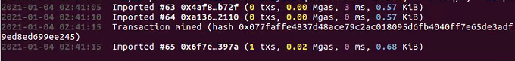

1. Compose a 2 nodes network

./openethereum - c node2.json

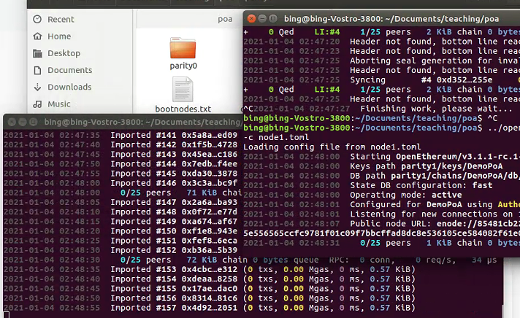

Without bootnodes, a new node cannot discover the peer node to boot up the network

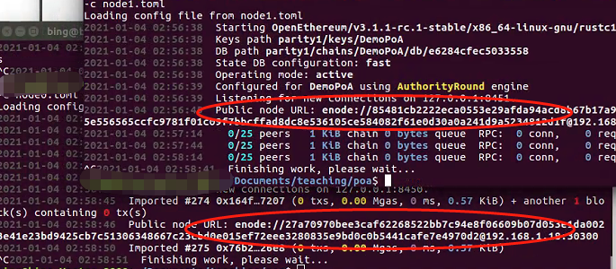

Add these to bootnodes.txt

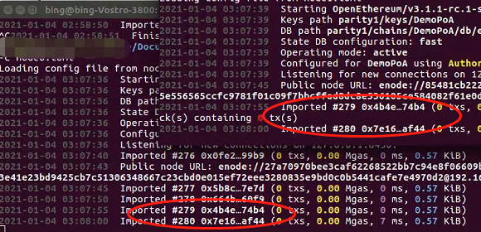

# Hard Fork

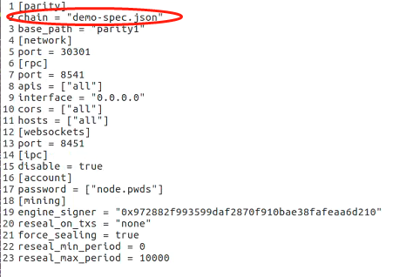

Change this to demo-spec2.json

Demo-spec.json

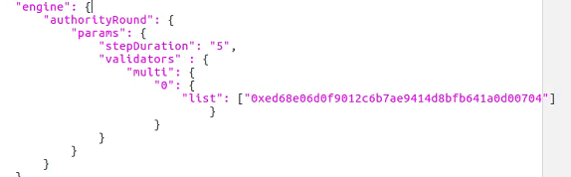

Demo-spec2.json

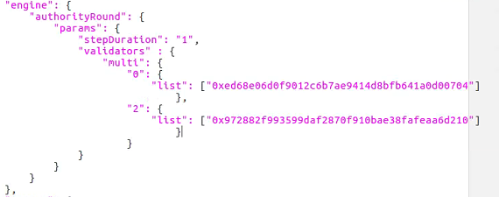

Fork from block 2

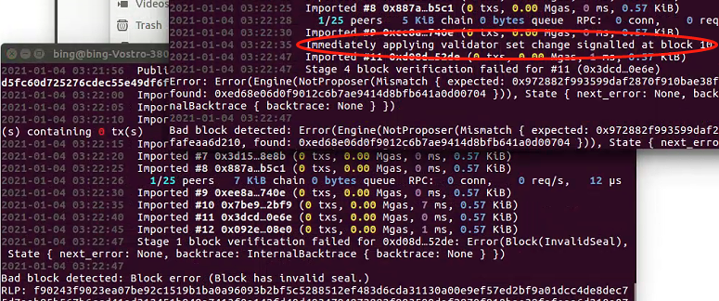

After Fork

